Lorne Street Values
RESPECT
RESPONSIBILITY
KINDNESS
TRUTHFULNESS

DIARY DATES
FORTHCOMING EVENTS

Friday 2nd November
P7 Induction Day at Bellahouston Academy
Wednesday 7th November
3.15 – 5.45 Parents Evening
Sunday 11th November
10.45 am - Group of P7 pupils presenting Rememberance Presentation at Harper Memorial Church
Wednesday 13th November
5pm – 8pm Parents Evening
Monday 19th November
Book Week Scotland
Monday 26th November
6pm Parent Council Meeting
Friday 30th November
1pm Christmas Fayre

Lorne Street Primary Newsletter
e-mail : headteacher@lorne street-pri.glasgow.sch.uk
Telephone: 0141 427 1315
November, 2018
Dear Parents and Carers,
Be at the Heart of Your Child’s Learning.
Research proves that children do better when families support their learning.
Your involvement makes a world of difference to your child.
See Parentzone website for practical advice and ideas.

If your child is in P1 – P3 follow Read, Write, Count on Twitter to see how you can include Reading, Writing and Counting in everyday activities.

Parent/Teacher Meetings

Parent’s evenings give you an opportunity to ask questions and share information about your child and their learning. The first meeting in November will allow the teacher to tell you how your child has settled into their new class.
If you need more time to speak to the teacher or want to follow up any issues with the Senior Management Team this can be easily arranged. We want to work with you to ensure your child reaches their full potential.

In the school we have many systems in place to ensure we do our best to help every child achieve at their highest level.

At the beginning of each session your child’s health and wellbeing is key to us therefore we want to build relationships and a team ethos in each class. Getting to know children as individuals takes time and we have pushed our first Parents Night back to November so we can share as much information with you as possible.
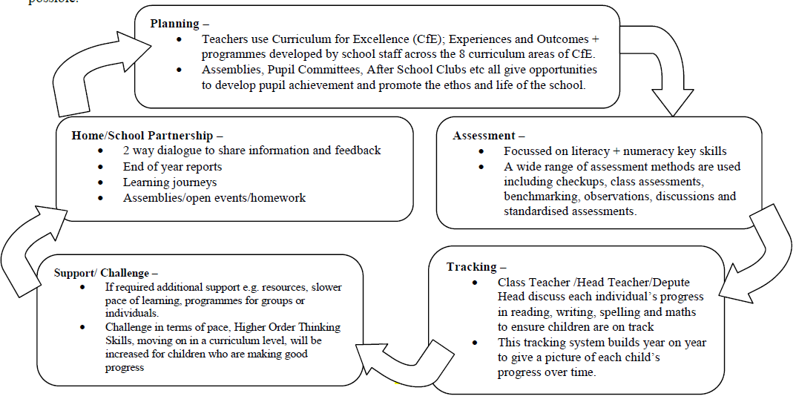

This cycle is repeated four times every year. We also have a calendar of visits for staff to observe each other and teach and share skills. Collegiate sessions occur some weeks after 3pm where staff share good practice and plan improvements to develop the priorities in the school improvement plan. Like you we have high expectations for every child in Lorne Street. Please let us know if you feel the processes are not meeting your or your child’s needs. If you have any comments please add them to the comment sheet at the end of the newsletter.

Sickness
Just a reminder that in accordance with the public health guidelines, children with diarrhoea and/or vomiting should be excluded until they have NO symptoms for 48 hours after an episode of diarrhoea and/or vomiting.
We recognise that children can often feel well within themselves long before they are symptom free for 48 hours, however they can remain infectious to others. We would be extremely grateful for your support to try and reduce the number of instances of infection/re-infection and best protect the health and wellbeing of all children and staff by observing the appropriate exclusion period if your child is unwell.

Head Lice
Please remember to check your child’s head regul;arly for any sign of infection. While lice are nothing more than a nuisance, it is important that children are checked on a weekly basis so that any head lice can be dealt with quickly and before they are allowed to spread too far. The following website www.onceaweektakeapeek.comwebsite has lots of information on how to follow a routine to ensure you are doing your bit to keep head lice to a minimum. For information on which treatment to use see your pharmacist. Can we also suggest that long hair is tied back or plaited.
Achievements Outside School
We are always keen to hear any achievements that children achieve outside school. Please encourage your children to come along to the Golden Bench on the Monday assembly, with any badges, certificates, trophies etc. that they have been awarded.
Each child will get an opportunity to tell the school how they achieved their award, a photo will also be taken and displayed on the achievement board in the gym hall. We will also share any achievements in the monthly school newsletter.
Book Week Scotland
Week Beginning 19th November, 2018
Book Week Scotland is a week- long celebration of books and reading. As part of book week, all P1 pupils will be gifted a Bookbug Primary 1 Bag which is produced by Scottish Book Trust in partnership with Education Scotland and the Scottish Government as part of Read, Write, and Count. The bag contains 3 brilliant picture books, an activity book and other resources to promote literacy.
Primary 2 & 3 pupils will receive a Read, Write and Count bag which contains books, fun counting games and materials for writing.
These bags are designed to inspire parents and children to read, write and count together. Please take some time to look www.readwritecount.scot and see how you can support your child’s literacy numeracy development.
For more helpful information on Book Week Scotland, please visit www.scottishbooktrust.com As part of non uniform day, we would encourage children to come to school dressed as their favourite book character on Friday 23rdNovember and bring a special or favourite book to share with their classmates.

Enterprise Committee
After many application forms and days of interviews we finally have a new Enterprise Committee who are extremely keen to get to work. The committee is made up of children from p4, 5, 6 and 7 who look at enterprising ways of working with all classes in Lorne Street. The children also help run the school shop which opens at playtimes on Tuesdays.

Enterprise Days
We are looking forward to running our annual enterprise days where classes come together and work in teams to make things to sell for our Christmas Fayre. Primary 4, 5, 6 and 7 Enterprise day will be held on Monday 26th November. and Primary 1, 2 and 3 on Tuesday 27th November. These days are always great fun and run smoothly with the additional support we get from parent volunteers. We are looking for volunteers for both days - if you are available to help can you please pop into the office and let Mrs. Hunter know.
Christmas Fayre
Our Christmas Fayre is not only a fun event but also the biggest fundraiser in our school calendar. Money raised for our school fund goes to buy additional items for pupils in Lorne Street that we may otherwise not be able to afford. We appreciate any support that you can give and are looking for donations for the tombola and Christmas hampers. We are accepting donations now, please hand in to school office.

PARENT/CARERS COMMENTS SHEET
Please use this slip for requests for more information or your opinion on how we are performing.

Signed ________________ Date_______________

Child’s Name___________________________________

