Lorne Street Values
RESPECT
RESPONSIBILITY
KINDNESS
TRUTHFULNESS

DIARY DATES

Tuesday 2nd October
Primary 1 Parent Workshop

Wednesday 3rd October
Cross Country Competition – selected pupils

Friday 12th October
In Service Day – School Closed to Pupils

October Week
School Closed Monday 15th to Friday 19th October (inclusive)

Parent Council Meeting
Monday 22nd October 6pm

Friday 26th October
Flu Vaccination Programme

Monday 29th October
Parent Council Halloween Party 6-7.30pm

Wednesday 31st October
P1 – P3 Infant Halloween Parade

Friday 2nd November
P7 Induction Day

Wednesday 7th November
Parent Evening

Lorne Street Primary Newsletter
e-mail : headteacher@lorne street-pri.glasgow.sch.uk
Telephone: 0141 427 1315
Dear Parents and Carers,
MATHS WEEK SCOTLAND
A big thanks to all our pupils, staff and families for their participation and enthusiasm for all the Lorne Street activities that took place during Maths Week Scotland. We loved seeing all the work that was being done at home and the photographs of maths work on twitter.
LATE COMING
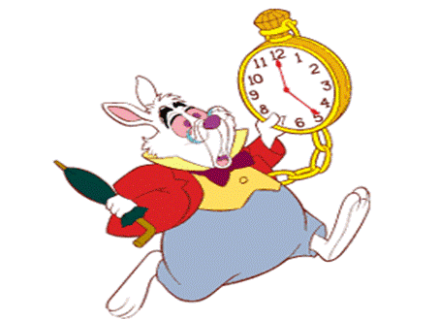
There has been a huge improvement in our attendance and late coming figures since returning to school in August. Good attendance and time keeping at school have a huge impact on our children’s learning – keep up the good work!
PARENT/TEACHER MEETINGS
Parent’s Evenings will be held on Wednesday 7th and Wednesday 14th November, 2018. We plan to hold one early Parents’ evening and one late one to give parents and carers a choice of suitable time slot. Parent’s evenings give you an opportunity to ask questions and share information about your child and their learning. This first meeting in November will allow the teacher to tell you how your child has settled into their new class.
If you need more time to speak to the teacher or want to follow up any issues with the Senior Management team this can be easily arranged. We want to work with you to ensure your child reaches their full potential.

HEALTH AND SAFETY
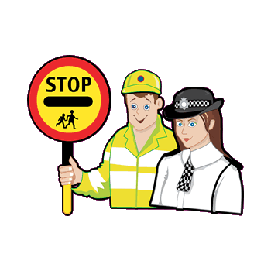
Our Junior Road Safety Officers are working hard to ensure that our parents/carers are not double parking or parking on the zig zags outside the school. We have seen a huge improvement in parking and ask you to support us in keeping your child safe by encouraging them to cross with our lollipop man when crossing the road. Please do not call children to cross the road independently. Thank you for your cooperation.

PARENT/CARERS COMMENTS SHEET
Please use this slip for requests for more information or your opinion on how we are performing.

Signed ________________ Date_______________

Child’s Name___________________________________

