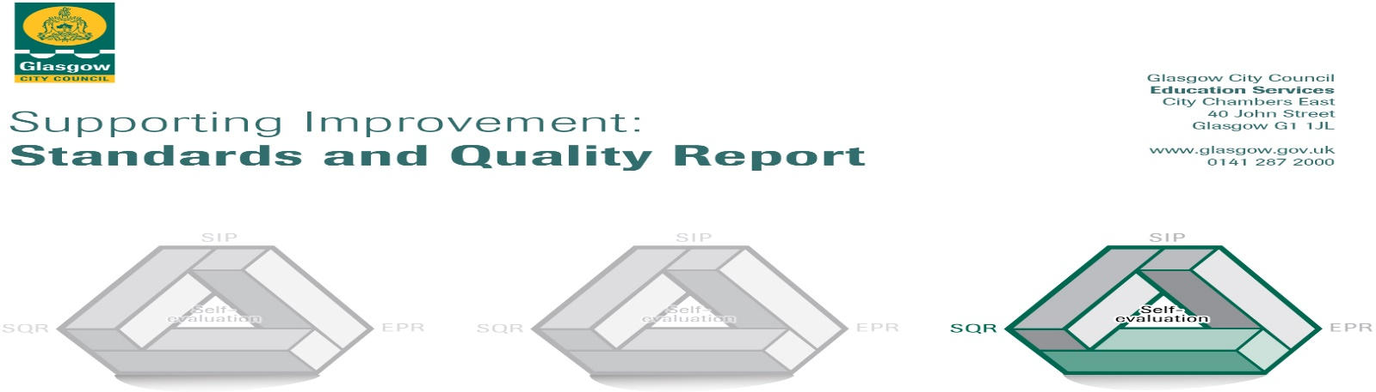

The summary report is provided for parents/careers and partners to outline our achievements this session and our priorities for next session. Throughout this session we have taken forward our priorities as detailed in our school improvement plan. Through our processes of self-evaluation, we have identified how we can improve outcomes for our children and young people.

Our achievements and improvements this year.
We would like to highlight the following improvements/achievements:
During 2017/2018 our improvement priorities were:

- To raise attainment in Literacy through improving learning and teaching across the school in Reading skills / strategies:
Lessons in Literacy are now more active and collaborative. Teachers introduced a range of new reading strategies. Staff engaged in group discussions to reflect on experiences and share ideas. A successful Early level Literacy Family workshop ran where strategies / interventions were shared with parents / carers. Parents / Carers were then able to raise attainment as they were more skilled and confident in supporting their children’s learning at home. We employed a Child Development Officer with additional funding who supported children working at the Early level to develop Reading skills. Support for Learning Workers were trained to deliver a ‘Three Read Approach’ programme to some pupils which enhanced and developed Reading skills. The Pupil Equity Fund (PEF) allowed us to employ a member of staff dedicated supporting children’s learning in Literacy. This has had a positive impact on attainment in Literacy.

- To ensure that the needs of all learners are met and ensure appropriate pace and challenge for all children in the school by tracking pupil’s progress in Maths, Reading and Writing:
Staff starting using skills progression pathways which have been developed by Glasgow City Council – Glasgow Counts (Maths) and Literacy for All (Literacy). These pathways ensured that lessons in Maths and Literacy are more challenging, active, enjoyable as well as being more relevant to the children in helping to develop life ling learning skills. There is also more personalisation and choice now in Maths and Literacy lessons. To help ensure that everyone has the same expectations, staff have planned lessons together, taught the lessons as planned and then engaged in professional dialogue to evaluate the lessons. Teachers meet termly with the HT to discuss how each child is progressing in Maths, Reading and Writing and identify where more support and challenge is required. This has had a positive impact on attainment in Maths.

- To raise attainment in Numeracy through improving learning and teaching across the school:
Staff worked together closely to in what achieving a level in Maths looks like, as a result staff are more confident in identifying where pupils gaps in Maths learning are and putting in place necessary next steps. Staff undertook a variety of assessment techniques which has helped to clearly show the progress of each child in Maths. Staff and pupil surveys were carried out to help understand confidence levels and attitudes to Maths. Parents’ views were also sought through a survey at Parents’ Night. Maths workshops were also offered to parents to improve their skills in supporting children with their Maths homework. All staff went on additional training on teaching and learning in Maths. Maths is also a monthly focus at weekly assemblies which links with a home learning task. We have also developed our Maths profile across the whole school and community, inviting business partners to come into school whenever possible, to share with pupils how Maths can be used in the World of Work.

Here is what we plan to improve next year.
- In order to embed what has been achieved last session and further raise attainment the focus will remain on Learning, Teaching and Assessment to ensure provision of the highest quality learning experiences for all young people ensuring children maximise their successes and achievements at school.
This will include our Curriculum Rationale (what Lorne Street means to different stakeholders and the vision for the school) being updated. Digital Learning will be at the heart of developments this year with learners being able to exercise choice, including the appropriate use of digital technology and taking increasing responsibility to ensure that they become more independent in their learning. We will be developing our learning skills pathways in Phonics, Spelling and Handwriting to ensure more consistency across the school. We will continue to review assessment and moderation approaches to ensure that the assessments we use are most helpful.

- Focus on implementing Quality assurance to ensure that all staff continue to have high expectations for all learners and are committed to change which results in continued improvements for learners.
We will continue to engage with the Glasgow Counts programme to enhance the way we teach Maths. We will continue to engage with the Literacy for All programme to enhance the way we teach Reading and Writing. The Pupil Equity Fund (PEF) has again this session allowed us to employ an additional member of staff dedicated to supporting children’s learning in Literacy. This member of staff will work across all stages in the school and will all teachers. All work undertaken in relation to this priority will be Quality assured to ensure that improvements can be measured and next steps appropriately identified.

- Focus on achievement in the widest sense including Family Learning to improve attainment over time to ensure children maximise their success and reach their potential at school.
All staff will consider achievement in the broadest sense and recognise and value personal achievements of all learners. All achievements for every single child will be tracked and celebrated ensuring improved outcomes for all. Family Learning will lead to stronger home - links which are improving outcomes for children. Participation in Family learning activities are monitored robustly to highlight trends and support effective early intervention strategies.

How can you find out more information about our school?
Please contact us directly if you require further information or if you wish to comment on the report.

The contact e-mail address is: Headteacher@lornestreet-pri.glasgow.sch.uk

Our telephone number is: 0141 427 1315

Our school address is: Lorne Street Primary School, 28 Lorne Street, Kinning Park, Glasgow, G51 1DP
Our web address is: www.lornestreet-pri.glasgow.sch.uk

Our Twitter feed is: @LornestreetPS

Further information is available in: newsletters, the school website, and the school handbook

