Lorne Street Values
RESPECT
RESPONSIBILITY
KINDNESS
TRUTHFULNESS

DIARY DATES
2nd March - World Book Day
6th – 10th March – Parent Council Meeting
6th March – Sexual Health and Relationships (SHRE) week
7th March – 8.30am – 9.30am Fair Trade Breakfast
8th March –115pm -3pm Paired Reading Parent Workshop / Topic showcase all classes
8th March – 7.30pm - GHA Dance Show @ Govan HS
9th March – 10.30 and 1.45 – P6 to Festival Park Nursery for International Education Week
9th March – International School Meals Day
9th March – 11.30am P7 to Fairfield Heritage Centre to hear Govan residents tell historical stories
16th March – 5-6pm Active Schools South West Dance Heats at Hillpark Secondary
16th March – Euro Quiz- 4 p6 pupils represent Lorne Street
20th March – P5-P7 1.15-2.45 Baldy Bane Theatre Company Safety Performance & Workshop
24th March – Red Nose Day
25th March – Earth Hour
27^{th-} 31st March – Charities Week
Friday 31st March – Non uniform day & School closes @ 2.30
Tuesday 18th April – Pupils return
1st May – Eco / Science week

Lorne Street Primary Newsletter
e-mail : headteacher@lorne street-pri.glasgow.sch.uk
Telephone: 0141 427 1315
Car parking
I am calling on all parents/carers to take responsibility and ensure that all children are protected as they come and go to school. Please do not double park or park on the zig zag lines. Parking in these areas is inconsiderate and affects the flow of traffic around the school.

World of Work Day
We had a very successful world of work event in school on Wednesday last week. We had an engineer, hairdresser, chef, nurse, policeman and many more. This was a great opportunity for children to find out about different jobs and ask questions. We would especially like to thank local businesses Lets B Wise and Dunlop, Allen & Co for taking part.

Reading Websites
World Book Day is on Thursday 2nd March. This will be a non uniform day and your child should come in dressed as their favourite book character on this day and if possible take in £1 which will go towards the school fund. As part of World Book Day, we will also have some special visitors coming in to read their favourite stories to classes. Some of our visitors include a local Councillor, School Chaplain, Epilepsy Scotland and Mrs Kelly, Head Teacher from Festival Park Nursery.
Here are some websites you might find useful to encourage your child with reading.
- Booktrusted: www.booktrusted.co.uk/education has a list of recommended books.
- Scottish Book Trust: www.scottishbooktrust.com/children-and-young-people has a books section where you can search the book database and find the latest new books.
- UK Children’s Books: www.ukchildrensbooks.co.uk. Here you will find links to authors, illustrators and publishers websites.
- Achuka: www.achuka.co.uk has recommended books for all ages. Find out about the latest books as well as information about authors and illustrators.
- Stories from the Web: www.storiesfromtheweb.org allows children to get their writing published on the web. They can also send in their poems, stories, reviews, raps and songs. Stories and games also feature.
- Oxford Owl: www.oxfordowl.co.uk Help your child’s reading, includes over 250 e-books suitable for children aged 3 – 11 and a variety of activities and advice.

EARTH HOUR
Climate change remains the most serious problem we face – changing weather patterns, warming seas and melting ice are devastating for both people and wildlife. Urgent global action is needed if we are to avoid the worst impacts of climate change and safeguard our world. Lorne Street Primary is again uniting with schools across Scotland, the rest of the UK and the wider world for signing up for WWF’s Earth Hour. Earth Hour 2017 takes place on Saturday 25th March at 8.30pm till 9.30pm. Hundreds of millions of people from across the world will come together and turn off their lights for one hour to show support for our planet in a symbolic and spectacular display. As an Eco School it is a great opportunity to be involved and the Committee will once again be encouraging all pupils and their families to do the same. The Eco committee will soon be delivering a presentation on Earth Hour to the school at assembly.

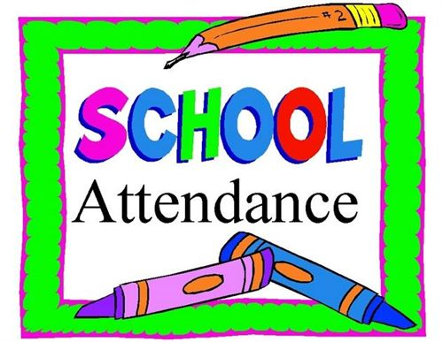
ATTENDANCE AND ABSENCE PROCEDURES
In developing their role as responsible citizens all children are encouraged to arrive at school punctually both in the morning and after the lunch break. There are an increasing number of children who regularly do not arrive at school in time to line up and enter the school with their class. We would appreciate your support in ensuring that late attendance is minimised where possible. Any children who are late and have to enter through reception will be recorded as late on the register. Parents/Carers are reminded that if a child is to be absent from school for any reason to call the absence line on 0141 287 0039 promptly each day and preferable before registration at 9am. If the school cannot account for your child’s absence, office staff will first try to contact you via a text message. Following this the Attendance Officer will be notified and if we still cannot account for the child, in line with Glasgow City Council Service Guidelines, the Police will be informed. To help encourage children to have their best possible attendance awards will be issued at the end of each school year. Children will be awarded with a certificate for the following:-
Gold = 100% Silver 95%-99% Bronze 90% - 94%

Twitter
Please join and follow us on twitter @LorneStreetPS for updates and information about what is happening in the school. (You can view our twitter feed on the school website or by typing @LorneStreetPS in google). Thanks to Mrs Mackay who does a great job coordinating the tweets for our school.

Fuel Zone
This is the third year of Primary 1, 2 and 3 being entitled to FREE school meals. Please make good use of this and encourage your child to take up their FREE school meal. You can follow @FuelZoneGlasgow on TWITTER too where you can see updates.

Fair Trade Big Breakfast
Lorne Street Primary will be taking part in the Fair Trade 2017 campaign and we are registered on the UK Fair Trade map. We are having a Fair Trade Breakfast again this year and you can buy a £1 ticket or pay on the door. The price includes fair trade tea, coffee or orange juice and toast with fair trade jam. Please come along on Tuesday 7th^{h} of March from 8.30am till 9.30am and help Lorne Street be part of keeping your breakfast fair this year.

School Uniform & PE Kit
Please ensure that children wear their school uniform and have an appropriate jacket/coat/footwear particularly during the unpredictable weather. A heavier, waterproof school jacket is available at a reasonable price and can be purchased from Border Embroideries at 35b Argyle Street Station, Glasgow. In addition, all children need their PE kit available in school. This should include indoor soft shoes, shorts and a t-shirt. Teachers will ask the children to take their PE kits home from time to time to be washed and to check that their shoes fit.

Parent Council
The Parent Council are always looking for ideas and extra help, particularly parent volunteers for fundraising events. So please come along for the next meeting and become involved in your child’s school, keep informed and make a valuable contribution. The next Parent Council Meeting is on Monday 6th March at 9am. You can also contact the Parent Council at lornestreetparentcouncil@outlook.com

RED NOSE DAY
Red Nose Day will be held on Friday 24th March. The Pupil Council will be selling Red Noses over the next few weeks at the cost of £1 each.

Primary 3 and 6 Survey
Each year, The University of Glasgow works with Glasgow City Council to find out about young people’s health and well-being. This helps to make sure that young people in Glasgow have the right sort of help and support that they need or will need in the future. Over the next two weeks primary 6 pupils will complete an individual questionnaire which will then be sent to the University to collate the results. Miss Clark, the Primary 3 teacher will complete the questionnaire on behalf of the Primary 3 children, and again the results will be sent confidentially to the University. If you have any questions or require further information, please contact Ms Tarbert, Principal Teacher.

EURO QUIZ – Primary 6
Primary 6 have just started on their new topic for this term, Europe. Four lucky pupils from the class will take part in the Glasgow Schools Euro Quiz, on Thursday 16th March at Our Lady of The Peace, Barlanark, at 12:45pm. Primary 6 will also be visiting the Festival Park Nursery in March, sharing their learning during International Week.

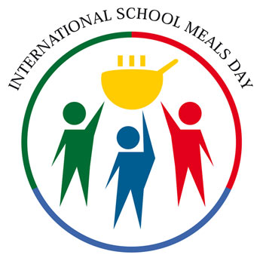
International School Meals Day
International school meals day is on Thursday 9th March, the menu for that day is:
Scotch Broth Soup (V), Sausage Stovies, Steak Pie, Clapshot Potatoes, Choice of Deli Selection, Shortbread, Choice of Pick-n-Mix Section. (All meats are halal).

Rights Respecting School
The rights Respecting School Committee will update you in the coming weeks with their own information leaflet. Please look out for it in the school bags.

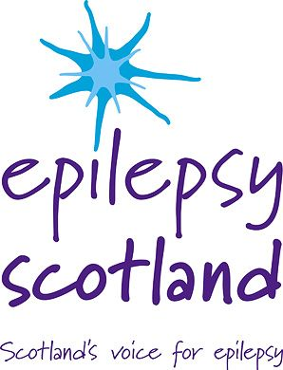
Epilepsy Scotland
At their recent Pupil Council meeting, the children highlighted that they are keen to support a local charity. One of the closest charities to our school is Epilepsy Scotland who are based at 48 Govan Road. Epilepsy Scotland will soon be coming to Lorne Street to deliver a whole school assembly. Following this the Pupil Council will come up with some suggestions on how we can support this local charity. If you have any ideas that you would like to give the Pupil Council please do not hesitate to get in touch with the school.
Language of the Month
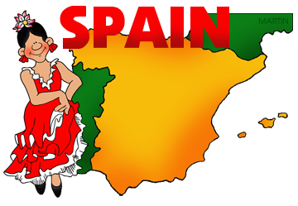
Our language of the month for March/April is Spanish. We are very fortunate to have a Spanish student Miss Isabel Quintero teaching in P7. As part of our learning focus for Spanish, Miss Quintero will visit all the classes at some point during March/April and teach Spanish. We also welcome any parent/carers who can speak Spanish to come in and teach the language. Please get in touch with the school if you are able to do this.
HOLIDAY DATES☰
Top of Form
Spring Holiday (Easter)
- Monday 3 to Good Friday 14 April 2017 (inclusive)
- Easter Monday 17 April 2017
* Please note that schools will close at 2.30pm on the last school day before the holiday
May Day
Monday 1 May 2017
May Weekend
Friday 26 and Monday 29 May 2017
School close
Tuesday 27 June 2017
Return date for teachers
Friday 11 August 2017
Return date for pupils
Tuesday 15 August 2017
September weekend
Friday 22 September 2017
Monday 25 September 2017
First mid-term
Monday 16 to Friday 20 October 2017 (inclusive)
Christmas/New Year
Thursday 21 December 2017 to Wednesday 3 January 2018 (inclusive)
* Please note that schools will close at 2.30pm on the last school day before the holiday
In-service days - all schools
- Wednesday 15 February 2017
- Thursday 4 May 2017 (To coincide with Election)
- Friday 11 August 2017
- Monday 14 August 2017
- Friday 13 October 2017
PARENT/CARERS COMMENTS SHEET
Please use this slip for requests for more information or your opinion on how we are performing.

Signed ________________ Date_______________

Child’s Name___________________________________

