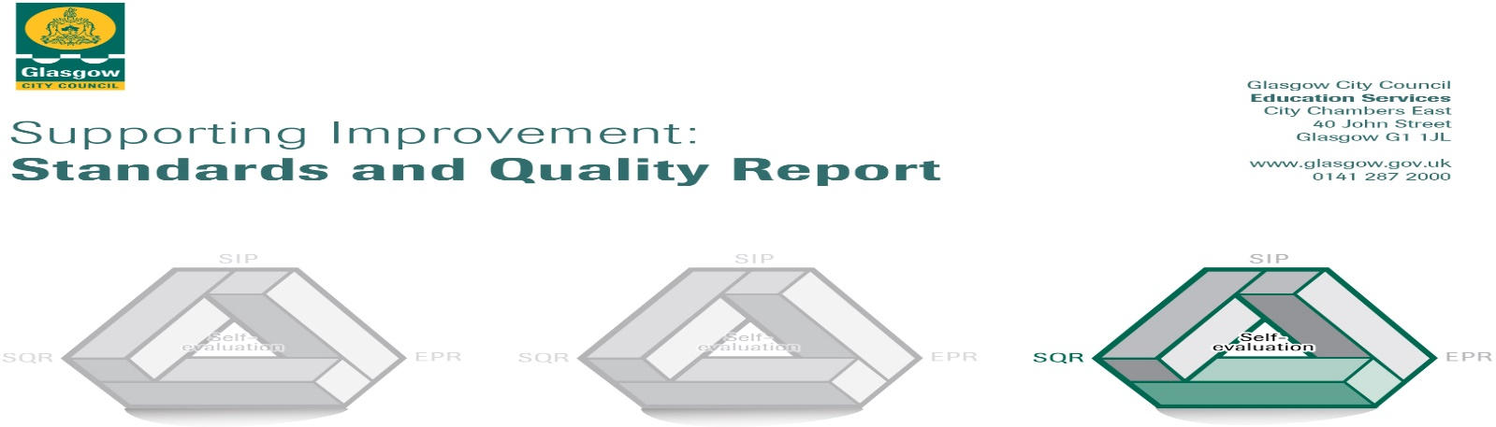

The summary report is provided for parents/carers and partners to outline our achievements this session and our priorities for next session. Throughout this session we have taken forward our priorities as detailed in our school improvement plan. Through our processes of self-evaluation, we have identified how we can improve outcomes for our children and young people.

Our achievements and improvements this year.
We would like to highlight the following improvements/achievements:
During 2021/2022 our improvement priorities were:

Improving Lorne street Curriculum, Well Being and Inclusion

Our school roll continues to increase and is currently 245 pupils (November 2022). We are a multi cultural school with children from Muslim, Christian, Hindu and Sikh backgrounds. We updated our ‘Curriculum Rationale’ to reflect our current demographic and increasing school roll. We have had a particular focus on developing how to teach topics which linked different subjects together. All staff received training in Equalities education and we have written a policy in relation to this, Some of our P6 and P7 pupils also managed to get some support from a third sector partner as part of their Health and well Being as they prepare for transition to secondary school.

Learning, Teaching and Assessment

Staff looked even more closer at how they could provide high quality learning experiences for every single child at Lorne Street Primary to help ensure that all pupils are reaching their potential at school. Teaching staff have undertaken training on Questioning and in particular looked at the type of questions they ask during lessons. The impact of this has been that teachers ask a more varied range of questions which encourages children to think in greater depth. Digital Learning…………………… The staff team have looked at more creative ways to take learning outside the classroom and into the playground. This has been particularly successful in Maths and Literacy where children enjoy taking their Maths, Reading and Writing lessons outdoors. To help ensure that all there is a shared standard and expectation from staff that teach in our 9 classes, a teaching and learning policy has been written. This has helped to ensure a more consistent approach in teaching and learning across the school. We have also been successful in raising attainment in Writing for targeted groups of children.

Raising Attainment and Achievement

We were able to offer Family Learning Classes in a variety of curricular areas which led to stronger home-school links and develop life long skills for both pupils and parents. All 9 classes are now using Seesaw as key way to communicate with parents. See Saw is primarily used as a communication tool for teaching and learning from school to home. Raising attainment has been successful in targeted groups with a particular focus on children who are New to English and those who benefit from support to stay on track with learning in Reading, Writing and Maths. Staff also looked closely at pieces of children’s Writing from P1 – P7 and looked closely at progression. This helped to ensure that all teaching staff had the same expectations in what progression looks like and what to look for in high quality pieces of Writing.

Here is what we plan to improve next year (session 2022/2023).
1.
Staff will continue to join look at how they can link together curricular topics when teaching topics with a particular focus on how to include more enterprise, outdoor education and skills for life. Staff will also ensure that what is being taught is relevant to what knowledge and skills children will need in the 21st century.

Staff will attend training on Outdoor Learning and how to use the local environment more to support teaching and learning. Digital learning resources will continue to be extended and there will a focus on using these resources more within teaching and learning in Maths and Language.

Using additional funding and staffing provided by the Scottish government, a Raising Attainment Team will be formed which will include teachers who will target intervention for groups of children in Reading and Writing.

Staff will continue to receive further training on how to support children with additional support needs and those who have English as an Additional Language.

We will continue integrate Digital Technologies into teaching and learning in all 9 classes across all 8 curricular areas. Staff will undertake even more training on what technology is best to use and how it can be integrated best within lessons. This will include training in a suite of new Apps.

2.
L
Staff will continue to offer an increased range of Family Learning Numeracy and Literacy workshops This will be offered at whole school and some at particular stages. This is to help further increase parental engagement.

We aim for all Support for Learning Workers (SFLW) to offer a more targeted support when in classes, with a particular focus on Maths / Literacy. SFLW’s will participate in training which will equip them to use strategies which will help to continue to raise attainment.

Staff will ensure that every single child’s needs in their class are being met by ensuring that the school work that they are receiving is not too easy but still offers challenge. Staff will work together collaboratively on considering best, how to ‘differentiate’ learning.

3.

We will work towards all teaching staff being able to participate and complete LGBT Education through the TIE campaign. This is a certified programme which helps to increase teachers’ knowledge and understanding, skill and confidence in teaching LGBT education.

Staff will consider in more depth how to integrate ‘Developing the Young Workforce’ into teaching and learning across all curricular areas. This will help to ensure that we are helping get children ready for the ‘World of Work’ when they leave education.

How can you find out more information about our school?
Please contact us directly if you require further information or if you wish to comment on the report.

The contact e-mail address is: Headteacher@lornestreet-pri.glasgow.sch.uk

Our telephone number is: 0141 427 1315

Our school address is: Lorne Street Primary School, 28 Lorne Street, Kinning Park, Glasgow, G51 1DP
Our web address is: www.lornestreet-pri.glasgow.sch.uk

Our Twitter feed is: @LornestreetPS

Further information is available in: newsletters, the school website, and the school handbook.

