Getting it Right for Every Child
(GIRFEC)

Lorne Street Primary

January 2020

This policy has been written by the school, building on national best practice,
Glasgow City Council and Education Scotland guidance.

Convention on the Rights of the Child

Article 28: Young people should be encouraged to reach the highest level of education they are capable of.
Article 29: Children’s education should develop each child’s personality, talents and abilities to the fullest. It should encourage children to respect others’ human rights and their own and other cultures.

Rationale
In Lorne Street Primary School we are committed to the provision of the highest quality education for each child. We are an inclusive school within an inclusive Authority where all children requiring support are given appropriate provision suitable to meet their particular needs.

We aim to provide an inclusive learning environment where pupils are encouraged to discover personal excellence through a balance of academic and individual achievement. As a school, we recognise that every child in Lorne Street is different and, in keeping with our values of Kindness, Respect, Responsibility and Truthfulness, we are committed to developing each person’s unique talents.

We focus on the development of the whole child, to develop their personality, health and wellbeing, abilities and talents.

At Lorne Street Primary, staff ensures that all children are treated fairly, equally and with respect. It is school practice to ensure equality in terms of opportunity, social background, race, religion, gender, sexual orientation and disability. Achievement and attainment for all pupils will be monitored and supported; challenge and opportunities will be provided to ensure equality.

Direct intervention can help pupils overcome any barriers to learning, both in the short and long term. GIRFEC lies at the heart of Curriculum for Excellence which enables teachers to plan flexible learning experiences which challenge and stretch all pupils, whilst providing consolidation opportunities for children who require additional support.

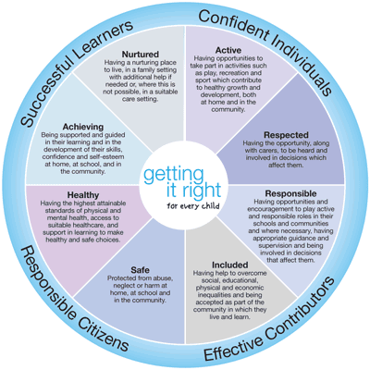

Aims
In Lorne Street Primary we aim to:

- provide a wide range of high quality learning opportunities to develop each child, enabling them to reveal, display and extend their skills and abilities, beyond the subject boundaries
- address the emotional and social needs of our pupils, especially where these needs cause barriers to learning
- ensure challenge and support in the curriculum for all pupils
- actively involve and engage children in their learning
- ensure that our pupils have a voice
- recognise each child as an individual and aim to develop the whole child, developing a recognition and awareness of their strengths
- continue to develop staff awareness, strategies and teaching skills
- improve outcomes for all pupils, taking account of SIMD
- promote out of school learning opportunities and support for pupils
- provide a supportive and caring environment in which the special talents and aptitudes of each child will be valued and nurtured
- encourage pupils to make positive choices
- provide opportunities for pupils to work collaboratively within a variety of groupings and contexts
- help pupils to develop the ability to evaluate their work allowing them to become self-critical
- offer support and advice to parents and involve parents in their child's education
- Liaise with nursery and secondary schools to ensure smooth transitions from nursery to primary and primary to secondary and consider how combined learning opportunities might enhance learning.

This policy is intended for:

i) Teachers, who should | - implement early intervention strategies  - recognise and be constantly aware of the wellbeing needs of each individual child through embracing the principles of GIRFEC within the SHANARRI framework  - liaise closely with the Additional Support Needs Coordinator in the identification of and provision for pupils with Additional Support Needs  - work collaboratively with a shared philosophy and commonality of practice and have access to specialist knowledge and services  - provide a challenging and stimulating programme of study designed to enable all children to reach the highest standards of personal achievement

ii) Pupils, who should | - be aware that the school is making provision to meet their needs  - develop a growing understanding of their own needs  - take responsibility for their own learning  - Be involved in setting outcomes within wellbeing plans (where relevant) and in evaluating success of implemented strategies  - Have a voice/say in how their needs should be met

iii) Parents, who should | - ensure early contact with the school to discuss matters which affect their child’s progress and / or behavior  - have their views taken into consideration and valued  - be fully engaged in their child’s learning by supporting the work of their child’s teacher(s)  - engage in discussions concerning their child’s progress and attainment  - offer encouragement and praise at all levels  - be kept informed about their child’s progress regularly

Targeted Support

Identifying areas of support is a continuous process.

Assessment data will be used to inform where targeted support will be directed in conjunction with teacher professional judgement.

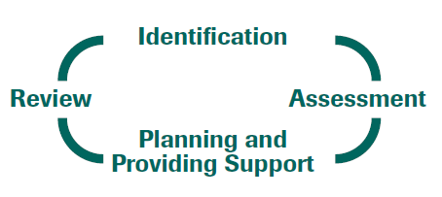

Organisational /Procedures /Classroom Strategies:

Support and Challenge is built into our curriculum.
Forward Planning will include Staged Intervention plans, evidence of differentiation and how support and challenge is being provided.
Support for Learning Workers are directed as required by the Class Teacher to support learning.

Roles and Responsibilities
Support for learning is the responsibility of the whole school team with the class teacher having the central role. The Head Teacher is responsible for the overview of all aspects of Support for Learning. The Additional Support Needs (ASN) Coordinator is responsible for the day to day operation of the implementation of the school’s GIRFEC Policy, collating materials and record keeping relative to Support for Learning. The ASN Coordinator should liaise with and advise colleagues as and when appropriate.
Other support services for the school are provided by relevant sectors of Social Work, Education and Health Boards may include:
- Sensory Impairment Services
- Psychological Services
- Speech and Language Therapy
- Occupational Therapy
- ICT Team for Additional Support
- Language and Communication Outreach Workers
- Voluntary Organisations

Support for Learning Workers
Our Support for Learning Workers work alongside and liaise with class teachers for the benefit of all pupils. They provide support for groups and individuals in class where appropriate. At times, a Support for Learning Worker may be asked to collect and collate information and data regarding children giving cause for concern prior to liaison with parents and internal and external agencies.
- To contribute as part of the school team to staff development programmes
- To ensure that resources are allocated equitably
- To encourage the use of ICT to remove barriers to learning

Additional Support Needs Procedures
A staged Intervention approach is used for pupils with additional support needs. When thinking about a child’s needs, it is important to approach this in a holistic way. The Wellbeing Assessment and Plan (WAP) should provide a holistic overview of the child’s wellbeing and is a means to plan for and record, the wellbeing needs and how the assessment of need has been reached.

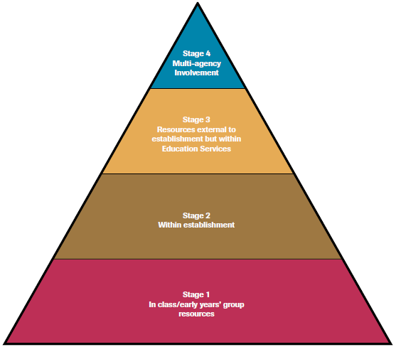

Initial Concerns
Children are identified by class teachers as experiencing difficulty in one or more areas. Class teachers should put in place strategies to support the child in liaison with the Support for Learning Team. Strategies and outcomes should be reviewed and where progress has not been made discussions should ensue with the Additional Support Needs Co-ordinator. Parents should be kept informed at all times. At this stage a wellbeing plan (stage 1) may be set up where appropriate and achievable short-term targets will be set by the class teacher. These plans are sent home and reviewed at regular intervals. Parental views are captured on the plans.

Referral to the Joint Support Team
If difficulties persist despite support in place, a pupil may be referred to the Joint Support Team. In Lorne Street Primary, this consists of the Additional Support Needs Co-ordinator, Class Teacher, and the Educational Psychologist. Where relevant, a Social Work representative may attend on an advisory basis along with health professionals, speech and language therapists, occupational therapists and physiotherapists (if relevant). Such meetings only take place with parental/carer consent and the purpose of this forum is to apply a solution-focused approach to getting it right for the learner in question. Feedback to parents/carers is provided detailing the outcome and action points as a result of the discussion. Children who have established involvement with other agencies are discussed through the Joint Support Team as and when appropriate with parental/carer consent.
Referrals to Other Agencies
On occasion, it may be that a pupil would benefit from referral to another agency, e.g. Occupational Therapy or it may be relevant for the school’s Educational Psychologist to engage in observational or one to one assessments. Referrals to other agencies are completed collaboratively between the class teacher and ASN Co-ordinator. When a child has involvement from other agencies, this is reflected in the wellbeing plan which becomes a level 2.

Child’s Multi-Agency Plans (CMAP)
Children with enduring complex or multiple barriers to learning, who require a range of additional support from external agencies and have an allocated social worker will require a Multi-Agency plan. In such cases, the lead professional is the allocated social worker. Education staff have opportunities to feed into Multi-Agency plans and liaise with other agencies regularly to ensure that the child’s needs are being appropriately met. A child’s wellbeing plan outcomes sits as part of the larger Multi-Agency Plan.
Co-ordinated Support Plans (CSP)

The co-ordinated support plan is a statutory document which is subject to regular monitoring and review for those children and young people who have one. The criteria is as follows:

a child or young person requires a plan for the provision of additional support if-

(a) an education authority is responsible for the school education of the child or young person,
(b) the child or young person has additional support needs arising from-
(i) one or more complex factors, or
(ii) multiple factors,
(c) those needs are likely to continue for more than a year, and
(d) those needs require significant additional support to be provided-
(i) by the education authority in the exercise of any of their other functions as well as in the exercise of their functions relating to education, or
(ii) by one or more appropriate agencies as well as by the education authority themselves.

Assessments

It may be appropriate for children to undergo additional assessments over and above the assessments previously planned for all children at a particular stage. For example, if there are concerns about a specific learning difficulty such as Dyslexia, steps will be taken in accordance with the authority’s Assessment and Intervention Guidelines for the Identification of Dyslexia. Dyslexia is a continuum and the levels of support required will vary from child to child. All teachers will apply dyslexia friendly strategies in their day to day teaching.

Social and Emotional Support

Children may require additional support in relation to behaviour, resilience or emotions either on a regular basis or as a one-off block. This support is achieved in a number of ways and such a need would be identified by a class teacher, a pupil support assistant, a member of the senior management team or a parent. The Additional Support Needs Co-ordinator will arrange for a suitable assessment or questionnaire to be undertaken by the class teacher (e.g. SELF framework to assess social interaction skills or the Boxall Profile). Where appropriate, parents will also be asked to complete questionnaires about a child’s interactions or behaviour out with school. This allows relevant targets to be set and support to be appropriately targeted through the relevant group. This may include, where appropriate, involvement in a Nurture Group. This is to support children who require time away from class and ultimately help to develop coping mechanisms which will allow him/her to attend class full times. These supports will be provided by a member of the support for learning team along with a Pupil Support Assistant or by the Additional Support Needs Co-ordinator. Impact of all interventions will be monitored and reviewed.

Highly Able Learners

When a child is identified as highly able through teacher observations and assessments, class teachers will ensure that their needs are being met appropriately through differentiated programmes of work, extension and enrichment across all areas of the curriculum.

We recognise that because each child is different, a specific programme may be needed to meet the needs of an individual. We are also aware that many of the needs of the child can be met outside the school timetable as well as within it.

Transitions

Where appropriate, children who require enhanced transition will benefit from an appropriate programme of visits and meetings as relevant. The Additional Support Needs Co-ordinator will liaise as appropriate with members of the senior management team and with pre-5 centres, secondary schools, the pupil and his/her parents/carers.

When pupils with additional support needs move to a new stage, a full transfer of information will take place and a detailed handover will outline the successful strategies used in the current session. These strategies will be used by the new teacher to ensure a smooth transition.

