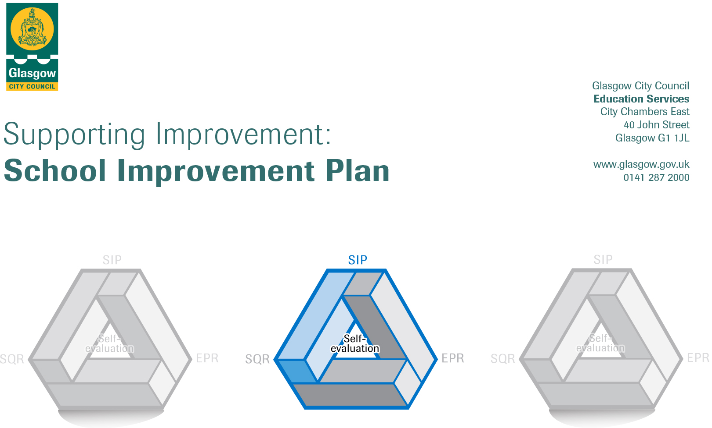

Session 2022-23
Establishment | Lorne Street Primary
Head of Establishment | Alex Nicolson
Local Improvement Group | LIG 2
Head of Service | Donnie Macleod
Area Education Officer/  Quality Improvement Officer/Link Officer | Louise Hamilton

CONTENTS
1. Vision, Values and Aims
2. Summary of Self-Evaluation Process / Priorities for Improvement in the current session
3. Additional Monies Spend Summary of Consultation Processes
4. Action Planning

Action Plan Summary for Stakeholders

1. Our Vision, Values and Aims
Vision
Our Vision is: Proudly Unlocking Potential In Lorne Street.
The first initial of each word spells out PUPILS who are at the centre of everything we do within our school to get it right for every child.

Values
Our School Values are Respect, Kindness, Truthfulness and Responsibility and we are committed as a school community to promoting and celebrating these.

Aims
- We strive to be welcoming, healthy happy, and for all to be safe (Article 4, 6, 19, 24, 28)
- We aim to learn new skills for a bright future with a strong focus on Developing the Young Workforce (Article 28, 29)
- We aim to respect ourselves and others and to be confident citizens through developing a sense of citizenship and responsibility in pupils and encourage independent learning, creative use of digital technology and developing life long learning skills (Article 12, 13, 29, 30)
- We aim to continue raising attainment in Literacy and Numeracy through Glasgow’s Improvement Challenge (Article 28, 29)
- We aim to improve how we meet the learning and care needs of children before they go to school and as they move through school, including how we support families (Article 23)
- We aim to develop children’s health and wellbeing with a focus on Glasgow City Council nurturing principles (Article 29, 30)
- We aim to utilise the UNCRC to ensure a rights based approach is immersed in all aspects of school life (UNCRC)
- We aim to develop Outdoor Learning ensuring that it permeates in all areas of our curriculum in school (Article 28, 29)

2. Summary of our self-evaluation process.
Lorne Street Primary is a school which strongly values the process and practice of self-evaluation. We intend to make our self-evaluation procedures even more robust in light of feedback from HMIE who visited the school in June 2017. It is valued as a core activity to the improvement of teaching and learning at Lorne Street Primary. Examples of self-evaluation include:
- Teacher’s Self Evaluation – of learning and teaching across the curriculum, on a termly basis to assist in developing the role of all teachers becoming even more reflective as practitioners. Part of this discussion also includes discussion at annual Professional Review and Development meetings.
- Quality Improvement Calendar of Activities – the calendar includes monitoring of forward plans, sampling of children’s work and learning experiences across the curriculum, formal and informal class visits by management, tracking of attainment, celebration of achievement, attendance monitoring, tracking progress in the school improvement plan, monitoring of formative and summative assessment practices.
- Improvement Planning 2021-2022- Staff were fully involved in setting priorities for session 2021-2022. We reflected on the progress made to date on our key priorities in last session’s improvement plan. Key priorities for 2021-2022. were also established through discussion, expectations of Curriculum for Excellence, GCC Priorities, Education Services Priorities, Getting It Right For Every Child (GIRFEC) as well as feedback that was received from an HMIE inspection that was completed in June 2017.
- Professional discussions – between senior leadership and class teachers continue as an important and valued aspect of self-evaluation and quality assurance procedures at Lorne Street Primary
- Standards and Quality Report Quality Assurance- audit also informed the new session’s priorities
- Pupil Committees – provide vehicles to ensure all children and young people are active participants in the life of the school. These committees include Eco, Pupil Council and Growing Citizens.
- Views of parents, children and partners – We value input from parents, pupils and school partners and are looking at alternative ways of collecting and collating information this session. The outcomes of this will be used to guide planning and improve practice within Lorne Street Primary.

Strengths identified:
1: The children’s positive approach to learning and the enjoyment and pride they feel for their school.
2: The clear, purposeful sense of direction the head teacher and senior leadership team are promoting in the school, winning the respect of the school’s community.
3: The caring ethos, identified by the whole school community, which the head teacher, senior leadership team and staff has developed
4: The way in which the school and its community recognise that the diverse, multicultural and inclusive nature of the school is a key strength and defining characteristic

Priorities for development:

1: Raise attainment by reflecting on, moderating and improving pedagogy across all classrooms.
2: Focus on improving and moderating our approaches to learning and teaching in Literacy.
3: Sustainability to permeate the curriculum, developing skills for life learning and work, rights of the child through IDL development and outdoor learning.

3. Additional Monies Spend Summary of Consultation Processes
Consultation Process:
Key stakeholders have been consulted in term 4 (2021-22).
Parents were consulted via a Survey Monkey and responses collated
Staff (Teaching and Non – Teaching) were consulted via a SURVEY MONKEY and responses collated
Pupil were consulted through whole class discussions with their class teacher

Funding allocation - £75,950 (PEF Fund). Additional 0.4 staffing.

Consultation on Review identified the following as suggestions for developments:
- Reconnecting with community / other schools / parents
- Update resources (particularly Reading)
- Extend even further opportunities for staff dialogue

Rationale for Spend:
- Additional staffing (0.4) provided - Targeted Intervention Groups inReading
- Core PEF Fund – Allocated - £75,950. Purchase additional class teacher (1.0) – Cost August 21 – March 22 - £58,890 and April 22 – June 22 - £23,004 to provide Targeted Intervention in Writing.

ALL STAFF HIGHLIGHTED IN RATIONALE HAVE NOW BEEN SECURED BY HR (JUNE 21) AND WILL COMMENCE POST IN AUGUST 22

Measures/Evidence for Impact (data, observation, views):
!. Class teachers will identify children who with intervention (Targeted Intervention Groups -TIG’s) could get back on track / stay on track. Quantitative and Qualitative data (professional judgment, tracking conversations, formative and summative assessments, class visits, ACEL data) will be utilised to identify which children would be in a TIG. Gaps in children’s learning will be clearly identified to inform what the content of each TIG should be in order to raise attainment and help children remain or stay on track. Duration of TIG intervention will vary depending on need – e.g. could last 6 weeks / a term.

4. Action Planning

No. | Quality Indicator | Priority
1 | 1.1, 1.2, 1.4, 2.3, 3.2 | 1: Raise attainment by reflecting on, moderating and improving pedagogy across all classrooms.

Tasks to achieve priority | Timescale  and checkpoints | Evidence of Impact > (data, observation, views)
IDL Development  Staff to meet in levels to create IDL idea grids for each social studies topic relevant to their level. These will detail suggested IDL links which staff could make when delivering  this topic and will also include ideas for enterprise, outdoor education and skills for life.  Yearly review of social studies topics, resources, relevance of IDL ideas grid etc. | Term 1 and 2 | Equity and sustainability embedded into Interdisciplinary planning (pupil focus groups, planning evidence, learning walls, skills progression, citizenship planners, pupil equalities) Seesaw, Assembly,  Increased engagement with Global Goals, collaboration, planning as a stage.  Agreed pathways and planning to support breadth and depth for all children
Moderation Activities  Re-establish moderation trios with a view of ensuring professional discussion on pedagogy and practice.  Moderation sessions and meetings planned throughout the academic year. Initial focus on moderation in Literacy.  Establish moderation partners with one other learning community school.  Engage in Authority Moderation Event February In-Service 2023 | Term 1- Term 4  Term 3 | Improved professional judgement. Colleagues will share good practice with one another and will develop professional groups within the school and within the learning community (examples of moderated tasks at all stages)  Improved skills in moderation as a stage.  Authority Moderation Information/ templates
ASN/EAL – supporting strategies and processes  Staff to continue to identify and provide relevant support to children who would benefit from additional support to meet their specific needs (inside and out with classroom)  Staff to receive training on a range of ASN/EAL topics  Digital Learning  Develop consistency of using digital technology to enhance teaching and learning across the school  DLOL to lead whole school CPD sessions on the new digital framework and identify staff training needs to inform areas for coaching in context  School use of Seesaw in every class, sharing learning, learning profiles, and communication tool with parents and carers  P5-7 to participate in SmartSTEM Digital Skills Programme | Term 1 -4  Term 1-4 | Termly training and staff development of supporting learners (staged intervention, learning conversations, attainment data)  Improved staff knowledge, skills and understanding. Improved pupil wellbeing. Parent partnerships.  Teaching and non-teaching staff can show improved knowledge and understanding of the needs of all children and demonstrate practical strategies to support children with ASN.  Up-skilled staff in writing appropriate social stories to support children who might benefit from them  Teachers incorporating digital learning into planning.  Increased digital learning observed during peer/trio visits  Teachers self-evaluations showing increasing confidence in the use of technology  Development of resource bank of digital materials in shared staff drive.  Parental interaction and engagement with Seesaw App.  Greater confidence and capacity in digital and STEM subjects.

Staff leading on this priority – including partners | Resources and staff development
Nuzhat Uthmani (IDL Development)  Karen Marigo (Moderation Activities)  Alex Nicolson / Pauline Murphy (ASN/EAL)  Digital Learning (Lindsay Kelly / Frances Zokas)  IDL Working Party – Staff members tbc | Resources  Professional Reading for all staff  Formative assessment resources  Collegiate /Staff Meeting/Training  Reading – Training and Development  Training ASN and EAL for all staff  Moderation activities timetabled  CPD for Teaching staff and SFL Workers  SmartSTEM Programme with GCC

No. | Quality Indicator | Priority
2 | 1.3, 1.5, 2.2, 2.3, 2.4, 3.2 | 2: Continue to focus on improving and moderating our approaches to learning and teaching

Tasks to achieve priority | Timescale  and checkpoints | Evidence of Impact > (data, observation, views)
GIC Year 6 – Literacy for All – Routes Through Writing  Audit staff CPD needs and current resources.  Continue the evaluation of current Literacy planning and progression pathways within the assessment framework  Create and deliver a programme of CPD in line with Glasgow Literacy for All. CHLOL to attend training from Glasgow Literacy For All and cascade information to staff  Baseline and final progress assessments to be administered to our children identified to track improved attainment over the year | Term 1-4 | All staff engaging with the school approaches as guided by GIC and CHLOL (Consistent and progressive planners and approaches, Resources, Literacy For All planners, Good Lesson checklist, Pupil Targets, Intelligent use of data informing improvements and targeted support. Parent and carer engagement (open lessons and workshops).  Staff feedback and attendance at CPD events. Learning Conversations with learners.
Family Numeracy’ and Literacy learning and workshops  Re-establish and deliver family learning opportunities including whole school maths activities to increase parental engagement | Term 1-4 | Attendance at events  Feedback – evidence of increased parental understanding of Numeracy and Maths  Engagement in children’s home learning tasks.
Integrating Digital Technologies into Teaching and Learning  All teaching staff to undertake training in a suite of new Apps to support learning and teaching | Term 1-4 | Staff feedback and attendance at CPD events  Learning Conversations with learners
Modern Languages 2+1  Staff briefing update at In-service day  Access CPD to support staff delivering French | Term 1-4 | Staff can define what Modern Languages 2+1 is.  Staff can clearly describe Lorne Street Primary’s position within 2+1 Languages  French being delivered throughout whole school P1-P7  French planners being implemented and progress discussed during Forward Planning meetings  CPD accessed and staff engagement in training sessions recorded on CPD record
Differentiation  Staff work together collaboratively to take forward ‘Differentiation’ using the ‘Collegiate Enquiry Practice’ ‘CEP’ model to help continue working together as a team to improve teaching and learning across the school. Staff will complete peer visits utilising the POLLI model highlighting new methodologies of Differentiation that they have implemented as a result of what has been learnt via the CEP process | Term 1- 3 | Observation of teaching and learning through POLLI model with a focus on ‘Differentiation’. Improved consistency of standards and expectations for children in relation to Differentiation will be evidenced across stages / levels  An increased range of Differentiation strategies will be utilised within lessons at all stages across the school enabling children to think about learning in more depth which will lead to raising attainment.

Staff leading on this priority – including partners | Resources and staff development
Freya Bachell - GIC – Year 6 – Literacy for All – Routes Through Writing  Lindsay Kelly- Family ‘Numeracy and Mathematics’ learning and workshops  Digital Learning (Lindsay Kelly / Frances Zokas)  K Marigo – French  All Staff – Differentiation | Glasgow Counts Framework and CPD  Outdoor learning training.  Awareness of apps / games / tools to support digitally.  Time spent bundling appropriate outcomes.  Time allocated for moderation within e.g. within IDL stage, across learning community.  Numeracy/ Maths with IDL.  Assessments  Sumdog subscriptions  Maths and Numeracy resources.  CPD Manager courses/ training  QIO Modern Languages Lead – access courses/training

No. | Quality Indicator | Priority
3 | 1.3, 2.2, 2.7, 3.1, 3.2, 3.3 | 3: Sustainability to permeate the curriculum, developing skills for life learning and work, rights of the child through IDL development and outdoor learning.

Tasks to achieve priority | Timescale  and checkpoints | Evidence of Impact > (data, observation, views)
Participation in the IDL Development  Embed Equity learning for sustainability within IDL planners ensuring children have clear pupil voice and actions | Term 1-4 | Equality and sustainability embedded into Interdisciplinary planning (pupil focus groups, planning evidence, learning walls, skills progression, citizenship planners, pupil equalities) Staff involvement and leadership.  Key areas of learning for sustainability being part of the IDL planners: Eco, Fairtrade, Global Citizenship, International Education, Rights, LGBT, Antiracism)
Certification on LGBT Education  Whole staff to participate and complete certification for LGBT Education through the TIE Campaign resource. | Term 1 - 4 | Curriculum will be more representative of LGBT groups, adding value to teaching and learning experiences.
Outdoor Learning Training  Develop consistent, high quality outdoor learning within the school to promote application of learning in literacy, numeracy and health and wellbeing.  Planning and implementation of Loose Parts Play Programme. | Term 1-4 | Training for staff in the understanding and development of outdoor learning.  Improved staff knowledge and confidence.  Outdoor Learning evident in Forward Plans – increased use of outdoor spaces by all classes within the school resulting in application of Lit, Numeracy, HWB learning for children.  Parental Engagement  Principal Teacher to create, with staff, a policy on outdoor learning including the management of resources.  Learners will have freedom to explore outdoor resources, build skills for life and work, increasing resilience and improved health outcomes.
Developing the Young Workforce  Create a DYW academic calendar.  Review planners identifying where DYW already exists within the school and identify gaps in curriculum. | Term 1-4 | Skills language development.  Events: Careers week. Career education.  Increased awareness of DYW and how this is embedded in our curriculum.  Improved links with community and local businesses.  Data to support children’s aware of the ‘World of Work’.  All stakeholders aware of the events within the life of the school and the opportunities to develop DYW approaches.  Children and parental engagement.  Pupils demonstrate an awareness of the skills for life.  Pupils will be an aware of the skills required for life and work e.g. organisation, communication, enterprise/employability, problem solving and teamwork/leadership  Skills language referenced in Seesaw. Skills language demonstrated in learning.

Staff leading on this priority – including partners | Resources and staff development
Nuzhat Uthmani – IDL Development  Lindsay Kelly – Outdoor Learning Training  Outdoor Learning working party – Staff tbc  DYW Working party – Staff tbc  LGBT training – All staff | Cooking Kitchen resources  Pupil Focus Groups  Staff Policies  Displays  IDL Planner  DYW – calendar  Work of Work Profiles

