Parent Pre-Selection
Guide to Ordering and Amending Meals via ParentPay

Allergens or Agreed Diets: for those pupils that have an agreed allergen or medical diet, their personal menu daily choices are not on the system. The pupil & their parents will continue to agree with catering what the pupil will eat from their menu. On the system there are only the choices to record a meal required, packed lunch, eating out of school, or a packed lunch for a school trip.
Absences: if you child is absent from school and you have already ordered their meal, please cancel this before 8am on the day of their absence. Guidance on how to do so, is below.
Trips: when the school office set-up trips on ParentPay, parents can also book a packed lunch for the trip (or the pupil can bring a packed lunch from home). However, this must be pre-ordered.
Booking in advance: once live, parents can pre-order meals up to 4-weeks in advance. Meals cannot be booked on holidays, no menu choices will be visible on these days.
Below you will find guidance on how to pre-order/amend your child’s meals. There are two versions fpr amending/cancelling meals, one for use on mobiles/tablets and another for use on laptops/PCs.

- Pre-Ordering Meals
Step 1 – Log on to your ParentPay account. Click on the ‘Make Meal Bookings’ box under the child
you would like to book meals for
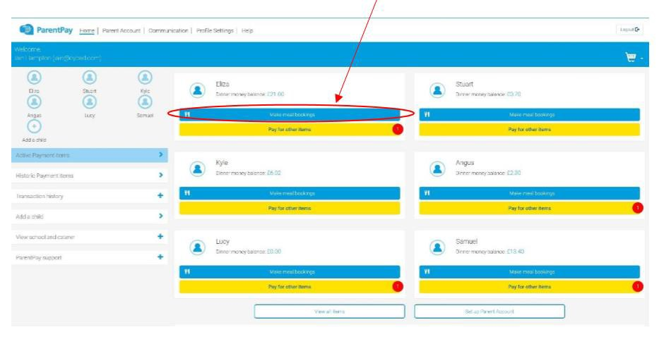

Step 2 – Ensure the drop down box is set to ‘Lunchtime’. Click ‘Make or View Bookings’

Step 3 – This will take you through to the menu where you can select the meals for your child. You can navigate through the available weeks, to select meals in advance, by clicking on the box under the date.
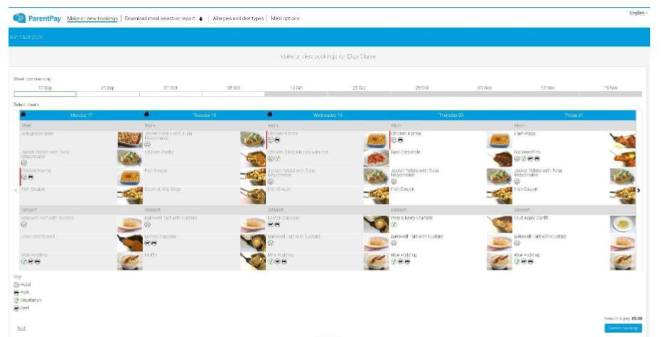

Step 4 – Once you have made the selections you must click ‘Confirm Bookings’ in the bottom right corner. If your child is UIFSM or FSM you will still need to follow through to payment screen, however the amount to pay will be zero and no payment will be taken from your account.
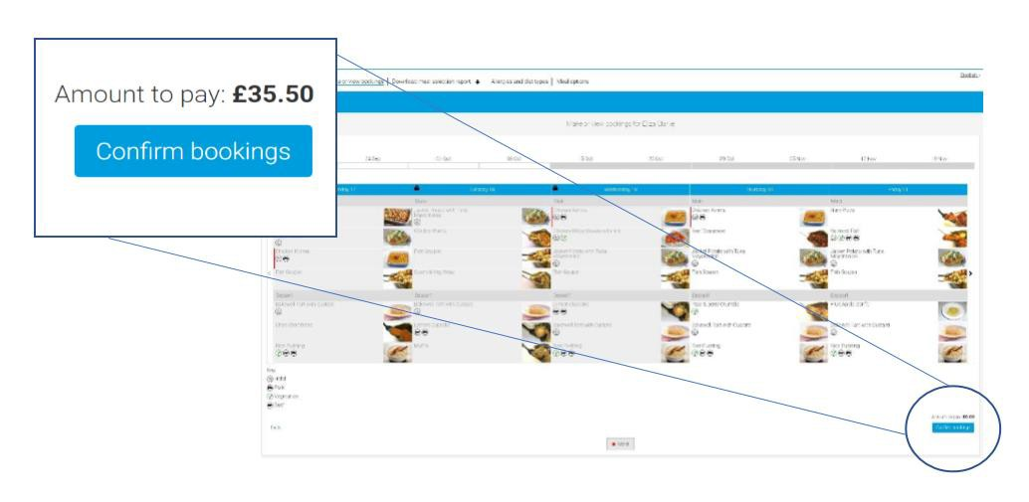
Step 5 – You have now confirmed your meal bookings.
If you would like to view the pre-selections you have made, you will need to go back through Step 1& 2 to reach the menu screen. You will see an option to ‘Download Meal Selection Report’, click this option and open the downloaded PDF file. This will show you all selections you have made for your child over the coming weeks. You can print this out and stick it on your fridge to remind yourself/your child what meal choice they are having on each day.

- Editing / de-selecting Meals in ParentPay – Mobile/Tablet
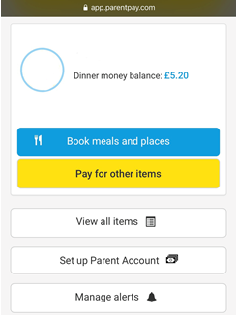
1. Login to your account and tap the “Book meals and places” button.

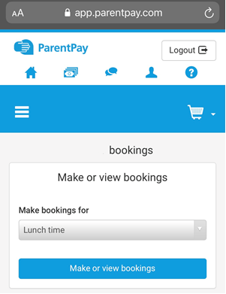
Child’s

2. Tap on the “Make or view bookings” button.

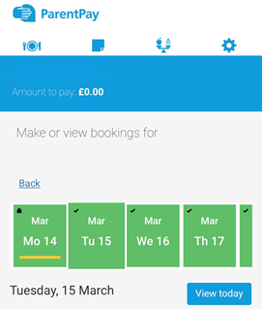
3. Today’s date will automatically be shown and underlined in yellow. (Please note that changes to the current day can only be made before 8am.)
To select a different day, press and slide the dates to the left or right then tap the correct day.

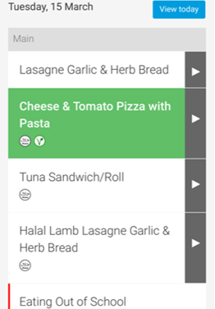
4. Once you have selected the correct day/date, scroll down to see the choice you have made for this day. It will be highlighted in green.
To remove this selection, tap on it to remove the green highlight.

5a Absent Children
If your child is / is going to be absent, do not highlight any of the options. Please make sure that you remove all pre-selections for every day of your child absence.

5b Changing the selection
If you wish to make another selection, tap on the new item to highlight it green as you normally would when pre-selecting a meal.

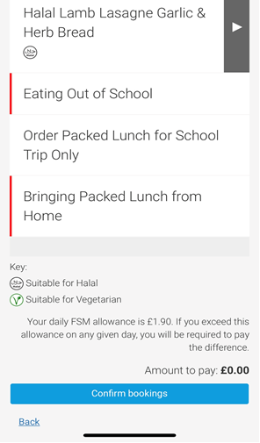
6. Once you have made the necessary changes to all relevant days, scroll down and tap “Confirm bookings” button.
You will then be taken to the confirmation screen to show your changes have been successful.

- Editing / de-selecting Meals in ParentPay – Laptop/PC

1. Login to your account and click on the “Book meals and places” button.

Child’s
2. Click on the “Make or view bookings” button.

3. This week’s menu will automatically be shown. All pre-selected meals are highlighted in green.
Any days which have the lock symbol on the date cannot be changed. Changes to the current day must be made before 8am.

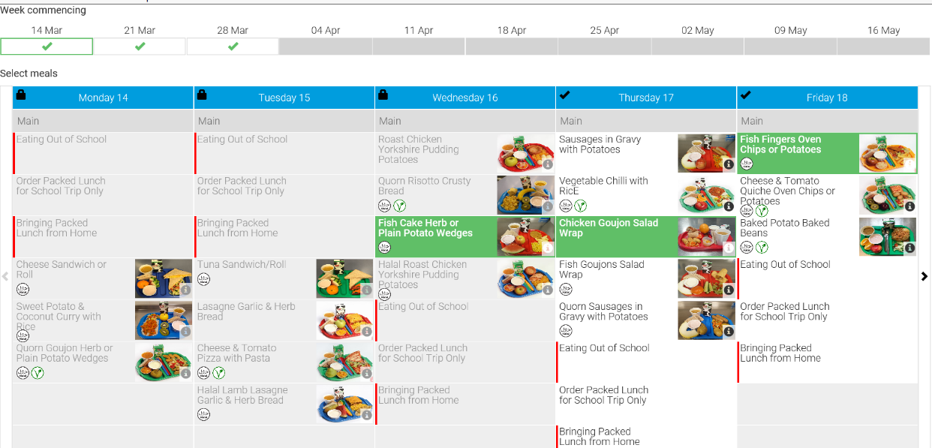

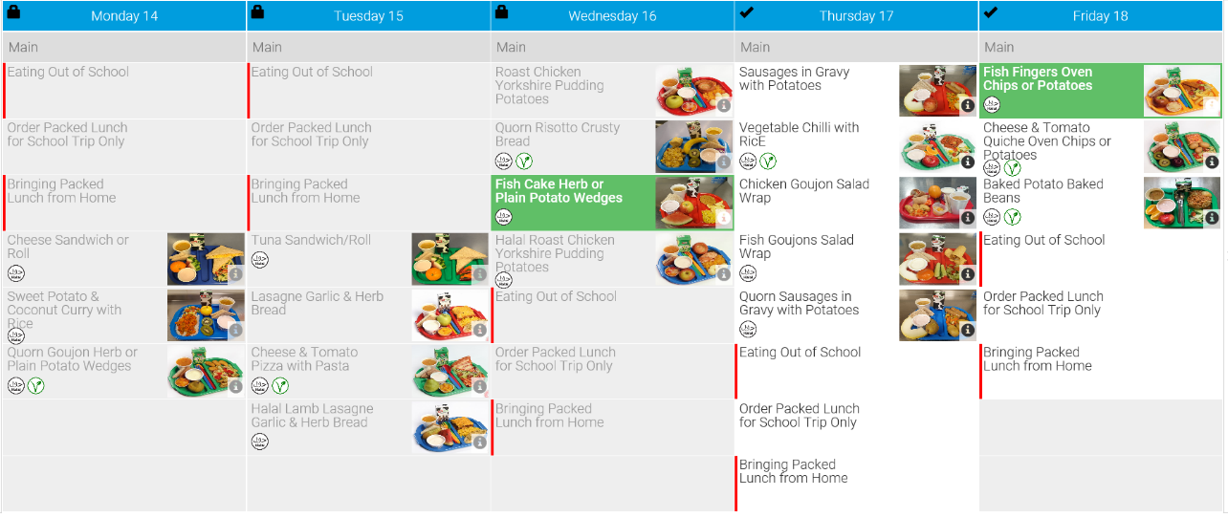
4. To remove a selection, click on it to remove the green highlight.

5a Absent Children
If your child is / is going to be absent, do not re-highlight any of the options. Please make sure that you remove all pre-selections for every day of your child absence.

5b Changing the selection
If you wish to make another selection, click on the new item to highlight it orange as you normally would when pre-selecting a meal.

6. Once you have made the necessary changes to all relevant days, scroll down and click on the “Confirm bookings” button.
You will then be taken to the confirmation screen to show your changes have been successful.

