Lorne Street Values
RESPECT
RESPONSIBILITY
KINDNESS
TRUTHFULNESS

DIARY DATES
Monday 9TH September, 2019
Rag Bag Collection

Monday 9th September
P1 Evening Times Photograph

Tuesday 17th September
P3 Kelvingrove Art Gallery - Fossils

Wednesday 25th September, 2019
P2 Kelvingrove Park – Minibeast Safari

Thursday 26th September
Non Uniform Day (dress as a Word) More details to follow

September Weekend
School closed Friday 27th and Monday 30th September, 2019

Maths Week Scotland
27th September – 3rd October

October Week
School closed Monday 14th – Friday 18th October (Inclusive)

Lorne Street Primary Newsletter
e-mail : headteacher@lorne street-pri.glasgow.sch.uk
Telephone: 0141 427 1315
Dear Parents and Carers,
As part of the strong relationship, Lorne Street Primary has with parents/carers, I would be more than happy to discuss any concerns you have with regard to any aspect of school life. Please feel free to make an appointment via phone or e-mail and we will do our best to try and help.

STAFFING/ SCHOOL ROLE
The school role at the moment is 208 and pupils are organised between eight classes:-

P1 Miss Hewlett
P1/2 Ms Deol
P2 Mrs Gunn/Mrs Akhtar
P3 Miss Clark
P4 Ms Zokas
P5 Mrs Mackay
P6 Ms Bachell
P7 Mr Munogee/ Ms Anwar
We welcome one probationer teacher, Mr Munogee, who is teaching P7. We also welcome Miss Bachell who will be teaching P6, she will work in Lorne Street on a permanent basis. Mrs Tarbert PT will be working on raising attainment in Writing as part of our Pupil Equity Funding. Ms Anwar will teach PE/Drama to all classes and provide Learning Support for Reading to P5, P6 and P7. Ms Akhtar will provide learning support to all classes in Maths as well as teaching P2 on a Thursday and Friday. Mrs Murphy will continue to work on a part time basis supporting children who have English as an Additional Language. Mrs Graham, Mrs Quinn Ms Seghal and Miss Frew will continue with their Support for Learning Worker roles and work in a variety of classes. Mrs Hunter will continue to work in the school office. Mr McDonald will continue as school janitor and Mr Orr as lollipop person.
Mrs Walker has started a new post in another school. Mrs Kelly was appointed as the new Depute Head role on a Monday and Tuesday. She will start on Tuesday 10th September.
STANDARDS AND QUALITY REPORT
It is compulsory that schools within Glasgow City Council produce a Standards and Quality report. This provides a brief outline on the school and the achievements made in the last year as well as where the school currently stands in relation to some aspects of teaching and learning.
If you are interested in finding out more, this can be requested from the school office.

The school website is a great way to communicate as much information as possible. We will soon be using the Lorne Street Primary School website a lot more to share information.
ATTENDANCE
The attendance of all pupils is always closely monitored. As you will be aware, Glasgow City Council has a strong push on improving children’s level of attendance. We would ask the parents do their best to ensure that they seldom or never take children on holiday during term time. Term time holidays will be recorded as unauthorised absences as following Glasgow City Council policy.
We ask if you could phone the Pupil Absence Reporting Line Service on 0141 287 0039. You can call this line each day from 8am. This is to ensure that staff always know whether a child is supposed to be at home or school on a particular day.
If there are any concerns regarding the level of a child’s absence, depending on the circumstances, the school may contact the Attendance Officer who would then get in touch with the parent/carer of that child.
Mrs Tarbert will continue to monitor late coming on a daily basis and record the names of any children who are late. Mrs Tarbert will also continue to monitor the attendance of all pupils in the school. The impact attendance and late coming on a child can be significant, please see the table below which highlights this.

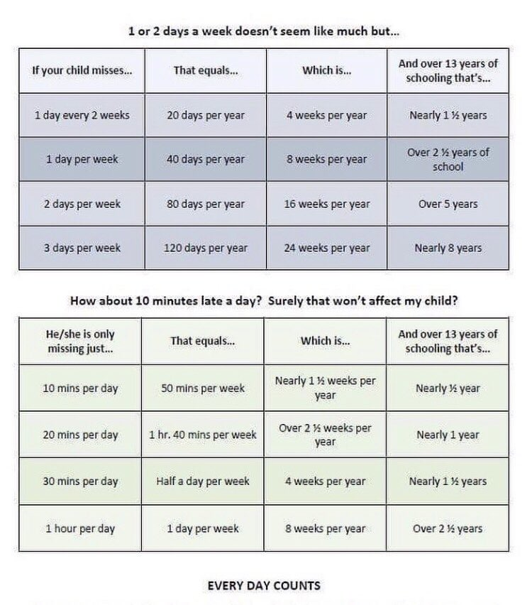

LATECOMING
Regular school attendance will mean that your child has a better chance in life. Your child will achieve better when they go to school all day, every school day.
Lateness has a negative impact on school life because being late can:
Disrupt lessons Affect achievement Embarrass/upset your child
Being late adds up to loss of learning:
5 minutes late every day adds up to 3 days lost each year
10 minutes adds up to 6 days lost each year
15 minutes adds up to 10 days lost each year
20 minutes adds up to 13 days lost each year
30 minutes adds up to 19 days lost each year
Is 80% good for school attendance?
An 80% mark in an exam may be good but 80% attendance through four years of school equal 1 full school year lost.
Being on time and at school means not missing out!
If your child is late or absent from school on a regular basis – maybe we can help. Please contact the school office to discuss any issues.

IMPROVEMENT PLAN
The improvement plan for the forthcoming session has now been finalised. Our priorities for the coming year are:-
      - Health and Wellbeing
Introduce a new Health and Wellbeing programme throughout the school
      - Maths
Develop Maths throughout the whole school community in line with the Glasgow Counts model.
      - Writing
Develop writing throughout the school in line with the improvement challenge.
      - Learning through Play
Introduce learning through play to P1
A copy of the plan is available at the school office and it will soon be loaded onto the school website. A copy can also be requested from the school office. If you have any questions about this, please do not hesitate to contact me.
PE KIT
School pupils will have 2 hours of PE every week. Class newsletters will notify you of specific days.
Can I remind you that jewellery cannot be worn during PE lessons and it may be a good idea that on PE days, jewellery is not worn at school at all.
WATER
As you know we encourage children to drink water during the school day to help learning. Children should bring water with them every day if possible.

PARENT HELPERS
I believe it is crucial that we build up as many partnerships with parents as possible. We would be delighted to hear from any parent or carer who feels that they would be able to contribute to the life of the school in some way. Have you a talent that you can share with a class, run an afterschool club or want to help planting in the playground. If you are available to help at any point this session, please fill in the attached pro forma.
COMMUNICATION
We are aware that at times we send a lot of information home via the school bags. Some forms are essential to the running of the school, eg trip/extra-curricular activity permission forms and require your signature. We would very much appreciate the prompt return of these forms to the school office. Other leaflets often come from Glasgow City Council or other local agencies and provide information which you or your child may decide to act on and which are offering opportunities out with the school environment.
NEWSLETTERS
The school newsletter is always produced in the first few days of each month and we try to give you all the information you require for the month ahead.

MEDICATION
Can we please remind you that it is Glasgow City Council policy that no medication (prescribed or non-prescribed) can be either self-administered or given voluntarily to your child by school staff without your prior written agreement. The relevant forms can be obtained from the school office.

UNIFORM
Children look very smart as they continue to wear the school uniform. We are also very impressed that children are wearing their uniform every day. This really helps show how proud the children are of their school. We will continue to monitor closely that pupils are wearing their school uniform.
We will have a non-uniform day on the last Friday of every month. It would be much appreciated if children could bring in £1 on this day which will go towards the school fund. A reminder will go out at the start of each non-uniform week.
There will be a tuck shop on this day where children can purchase juice, crisps etc. Thank you all for your continued support.
HOLIDAY DATES
Friday 27th and Monday 30th September 2019 School Closed
Monday 14th to Friday 18th October (inclusive) School Closed
ELECTRONIC ITEMS
Can we please remind all parents and carers that it is school policy that no ICT gadgets such as mobile phones or i-pads are to be used during school hours and on the school premises.
The school is not insured for any damage to such items.
Thank you for your co-operation on this matter.
PARENT COUNCIL
We have an active Parent Council who work hard to support the school. If you would like to be kept up to date about Parent Council matters by e-mail, please email lornestreetparentcouncil@outlook.com. The Parent Council will add you to the mailing list which will mean that you will get access to meeting agendas, minutes etc.
We are keen to recruit more parents on to the Parent Council. If you are interested please email the Parent Council or pop into the school and ask to speak to Mr Nicolson.
The Parent Council have now arranged afternoon meeting dates to hopefully make it easier for more parents to come along. This session’s meetings are planned as follows:
Monday 26th August, 2019 at 2.15pm
Monday 7th October, 2019 at 2.15pm
Monday 18th November, 2019 at 2.15pm
Monday 13th January 2020 at 2.15pm
Monday 2nd March, 2020 at 2.15pm
Monday 27th April, 2020 at 2.15pm
Monday 1st June 2020 at 2.15pm

FREE SCHOOL MEALS
All P1 – P4 pupils will continue to get a free school lunch.

Evening Times Newspaper P1 Photograph
As in previous years all P1 children have their photograph taken by the Evening Times. Our date is Monday 9th September at 2.30pm. Please ensure your child/children have their full school uniform worn on this day.

PARENT/CARERS COMMENTS SHEET
Please use this slip for requests for more information or your opinion on how we are performing.
Signed ________________ Date_______________
Child’s Name___________________________________

I am available to volunteer to help in school.
Name:
Contact telephone:
Child’s name Class:
Days Available:

